- Write 5³ in expanded form.
__________________________
- Write 7 × 7 × 7 × 7 × 7 × 7 in exponential form.
__________________________
- Evaluate 9⁴
_____________
- Circle all the perfect squares in the list below:
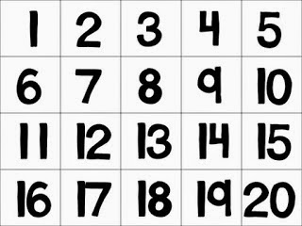
- Evaluate:
3 + 12(20 – 15)
- Which operation should you perform first when you evaluate the following expression? How do you know?
15 – 8 ÷ (4 – 2) × 3
__________________________

  - Find the greatest common factor of 24 and 32 using lists of factors.
24:
32:
GCF:
  - Find the greatest common factor of 24 and 32 using a Venn diagram.
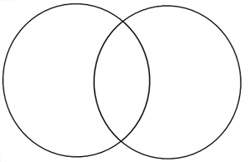
GCF:
  - Which method do you prefer? Why?
- You are creating identical candy bags using 18 chocolate bars and 30 peanut butter cups. What is the greatest number of bags you can create using ALL the candy?

